THE GREATER WORLD
FRIENDSHIP ENROLMENT FORM

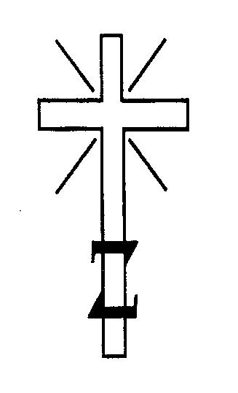
“Send forth your light and your truth,
let them guide me,
Let them bring me to your holy mountain to the place where you dwell.”

Psalm 43

Charity No. 212369. Scottish Registration No. SCO38680
THE GREATER WORLD BELIEF AND PLEDGE:
- I believe in one God who is Love
- I accept the Leadership of Jesus the Christ
- I believe that God manifests through the illimitable power of Holy Spirit
- I believe in the survival of the soul and its individuality after physical death
- I believe in Communion with God, with His angelic ministers, and with souls functioning in conditions other than the earth life
- I believe that all forms of life created by God intermingle, are interdependent, and evolve until perfection is attained
- I believe in the perfect justice of the Divine laws governing all life
- I believe that sins committed can only be rectified by the sinner himself or herself, through the redemptive power of Jesus the Christ, by repentance and service to others.

THE PLEDGE:
- I will at all times endeavour to be guided in my thoughts, words and deeds by the teaching and example of Jesus the Christ.

If you are in agreement with the Belief and Pledge, and would like to become a Friend of The Greater World, and promise to donate no less than £12.50 annually, please sign and complete your details below (BLOCK LETTERS PLEASE):

SURNAME.....................................................................................................................................................................................
FIRST NAME..................................................................................................................................................................................
ADDRESS.......................................................................................................................................................................................
..............................................................................................POSTCODE......................................................................................
TEL.........................................................................................EMAIL.............................................................................................
PROFESSION..........................................................................DOB................................................................................................
DATE..................................................................................SIGNATURE........................................................................................

I enclose remittance of £..................................................
ARE YOU A MEMBER OF ANY OTHER RELIGIOUS ORGANISATION?..........................................................................................
IF SO, PLEASE STATE WHICH........................................................................................................................................................
Please send your completed, signed form along with your donation to: The Greater World, 3-5 Conway Street, Fitzrovia, London, W1T 6BJ. (Please make cheques or postal orders payable to ‘The Greater World Association’). In the meantime, If you have any questions please call 020 74367 555 or email tgwfriendship@gmail.com.

